CS 255 System Design Document Template
By Marek Lubecki

UML Diagrams

UML Use Case Diagram

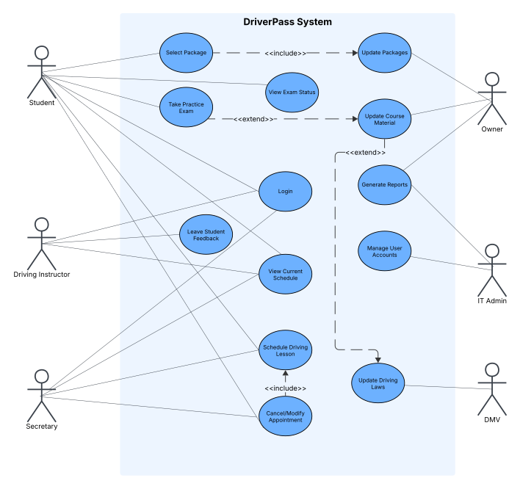

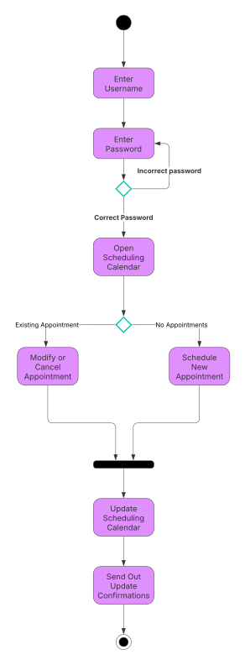
UML Activity Diagrams

Appointment Update Course Material Update
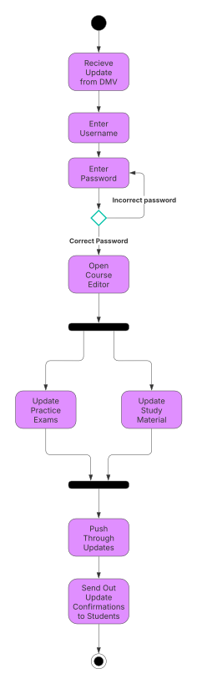

UML Sequence Diagram
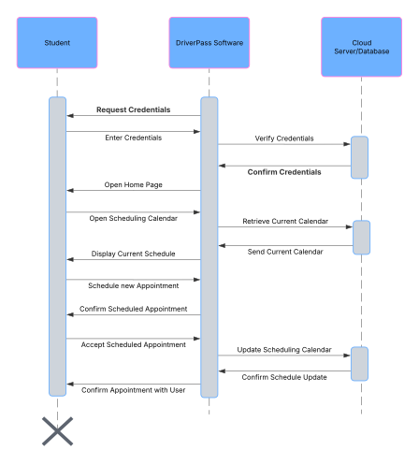

UML Class Diagram
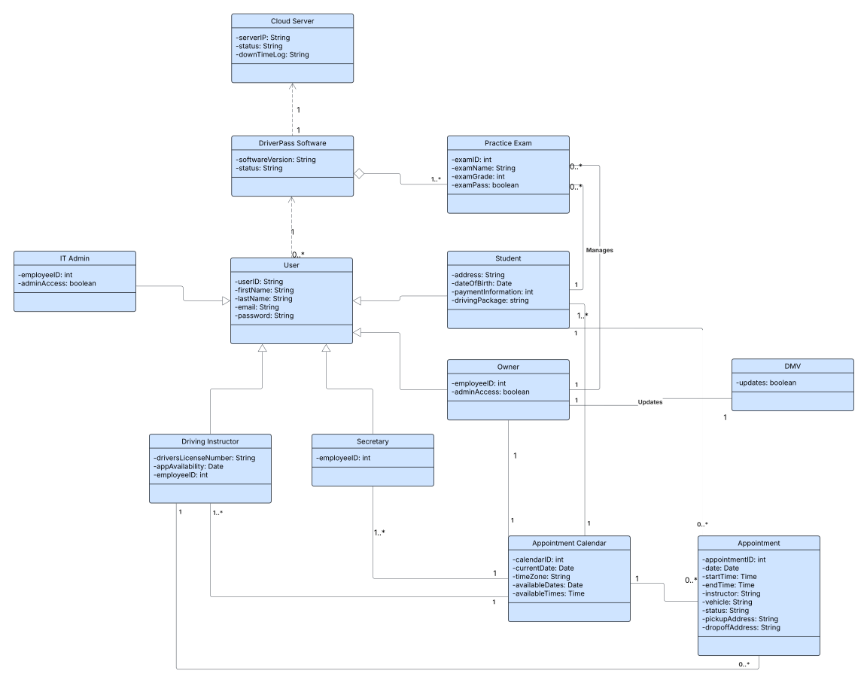

Technical Requirements

Based on my understanding of the client and their needs of the system we have the following technical requirements:
- Cloud-based environment hosted on a reliable platform.
  - Uptime percentage needs to be 99.9% so that anyone with a stable internet connection can access the website at any time.
  - The cloud infrastructure needs the ability to scale with website traffic and handle many users at a time.
  - Cloud system needs to be able to handle multiple microservices to handle things like payment processing and appointment scheduling.
  - All communications between the cloud server and users will be encrypted
  - The cloud system needs to automatically backup all the server data, and be able to reboot back to 100% upon failure
- Web-based application to run off the cloud. This application needs to run efficiently on any popular web browser and formatted for cell phone browsers as well.
- Secure database servers dedicated to storing personal user data and payment information.
- The system must implement Role-Based Access Control
  - This will allow It Admin to manage accounts, Owner to create and download reports, secretary to make appointments, etc.
- The system will implement authentication to verify secure log-in protocols such as multi-factor authentication.
- The main office of DriverPass will require a stable internet connection
- Each user will require a device with enough computing power to run the web-based application

